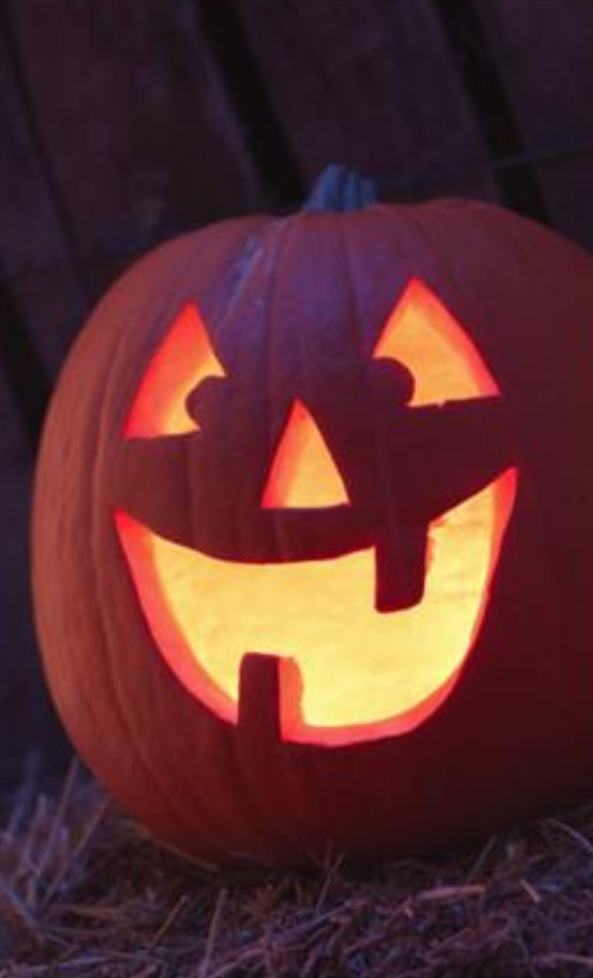
Halloween
Read the article bellow and then answer the questions.
What is Halloween?
Halloween is a traditional celebration that began in Europe hundreds of years ago. At that time, some people believed that ghosts of dead people visited living people. Nowadays it is a special day in several countries around the world, but it is perhaps most popular in Canada and the United States. It always falls on the same date every year: October 31. Around this time, people like to tell scary stories and watch horror movies. In the evening in October 31, children wear costumes. These are clothes that make them (1) look like interesting animals, monsters or people. They might be very funny or they might be quite scary. The costumes often include a face mask or some make-up painted on the person´s face. For example, on Halloween you might see a dinosaur or an elephant, a witch with a tall, black hat, or maybe even a ghost. Children then go from house to house and ask for candy by saying, “Trick or treat?” Many older kids and adults also put on costumes and go to Halloween parties. Jack-o´-lanterns are very common during this time. A lot of people like to put them (2) in their windows or just outside their doors. They are pumpkins with light inside and faces cut into them. In Mexico, a similar traditional celebration is called “The Day of the Dead” – family and friends come together for three days to pray for and remember people who have died. Most people, both young and old, have a lot of fun on Halloween. “Happy Halloween” everyone!
Reading comprehension
1 The article says in Canada and the U.S. dead people visit children.
A True B False C Yes, that´s true, but only on Halloween.
2 How long does Halloween last for?
A two days B three days C one day
3 Halloween is more popular in Canada than in the United States.
A True B False C It doesn´t say.
4 What does the word “them” (1) refer to near the beginning of the article?
A costumes B clothes C children
5 Why do mane people wear costumes on Halloween?
A They want to have fun. B They are afraid of ghosts. C They like to watch horror movies.
6 Halloween is a celebration only for children.
A True B False C It doesn´t say.
7 According to the article, where do children go to get candy on Halloween?
A other people´s homes B Mexico C Halloween parties
8 What do most pumpkins have during Halloween?
A faces B candy C windows
9 What does the word “them” (2) refer to near the end of the article?
A children B jack-o´-lanterns C doors
10 Most people have lots of fun during Mexico´s “Day of the Dead”.
A True B False C It doesn´t say.
Source: "What is Halloween?" Accessed November 30., 2017. http://busyteacher.org/17508-what-is-halloween-2-to-3-hour-complete-lesson.html.

