Halloween
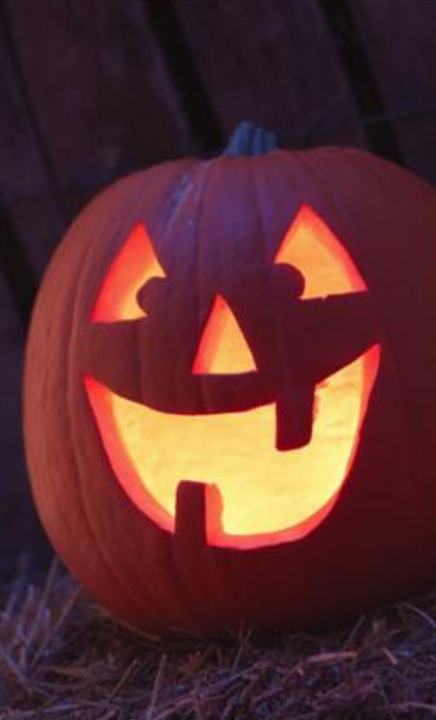
Read the article bellow and then answer the questions.
What is Halloween?
Halloween is a traditional celebration that (1)______ in Europe hundreds of years ago. At that time, some people believed that ghosts of (2)______ people visited living people. Nowadays it is a special day in several countries around (3)______, but it is perhaps most popular (4)______ Canada and the United States. It always falls (5)______ the same date every year: October 31. Around this time, people like (6)______ scary stories and watch horror movies. (7)______ the evening in October 31, children wear costumes. These are clothes that make them (1) look like interesting animals, monsters or people. They might be very funny or they might be quite scary. The costumes often include a face mask or some make-up painted on the person´s face. For example, on Halloween you might (8)______ a dinosaur or an elephant, a witch with a tall, black hat, or maybe even a ghost. Children then go from house to house and ask (9)______ candy by saying, “Trick or treat?” Many older kids and adults also put on costumes and (10)______ to Halloween parties. Jack-o´-lanterns are very common during this time. A lot of people like to put them (2) in their windows or just outside their doors. They (11)______ pumpkins with light inside and faces cut into them. In Mexico, a similar traditional celebration is called “The Day of the Dead” – family and friends come together for three days to pray for and remember people who have died. Most people, both young and old, (12)______ a lot of fun on Halloween. “Happy Halloween” everyone!
Grammar – in – Context
1 A begins B beginning C began D begin
2 A deadly B dying C die D dead
3 A world B a world C the world D worlds
4 A in B on C at D to
5 A at B on C to D in
6 A tell B to tell C told D tells
7 A In B At C To D On
8 A see B sees C saw D will see
9 A at B with C on D for
10 A going B goes C go D went
11 A are B is C was D be
12 A has B have C having D are having
Source: "What is Halloween?" Accessed November 30., 2017. http://busyteacher.org/17508-what-is-halloween-2-to-3-hour-complete-lesson.html.

