O
- rich x poor | - easy x difficult
- happy x sad | - sharp x blunt
- cheap x expensive | - heavy x light
- deep x shallow | - empty x full
- loud x quiet | - funny x boring
- late x early | - new x old

pposite adjectives

Přiřaďte přídavná jména z nabídky k obrázkům:

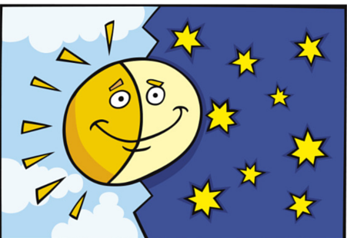
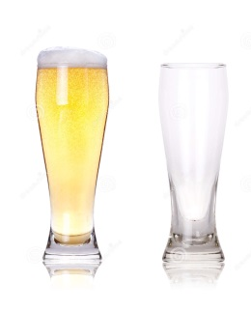

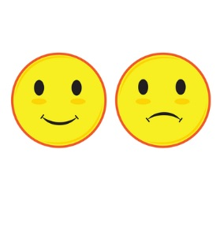
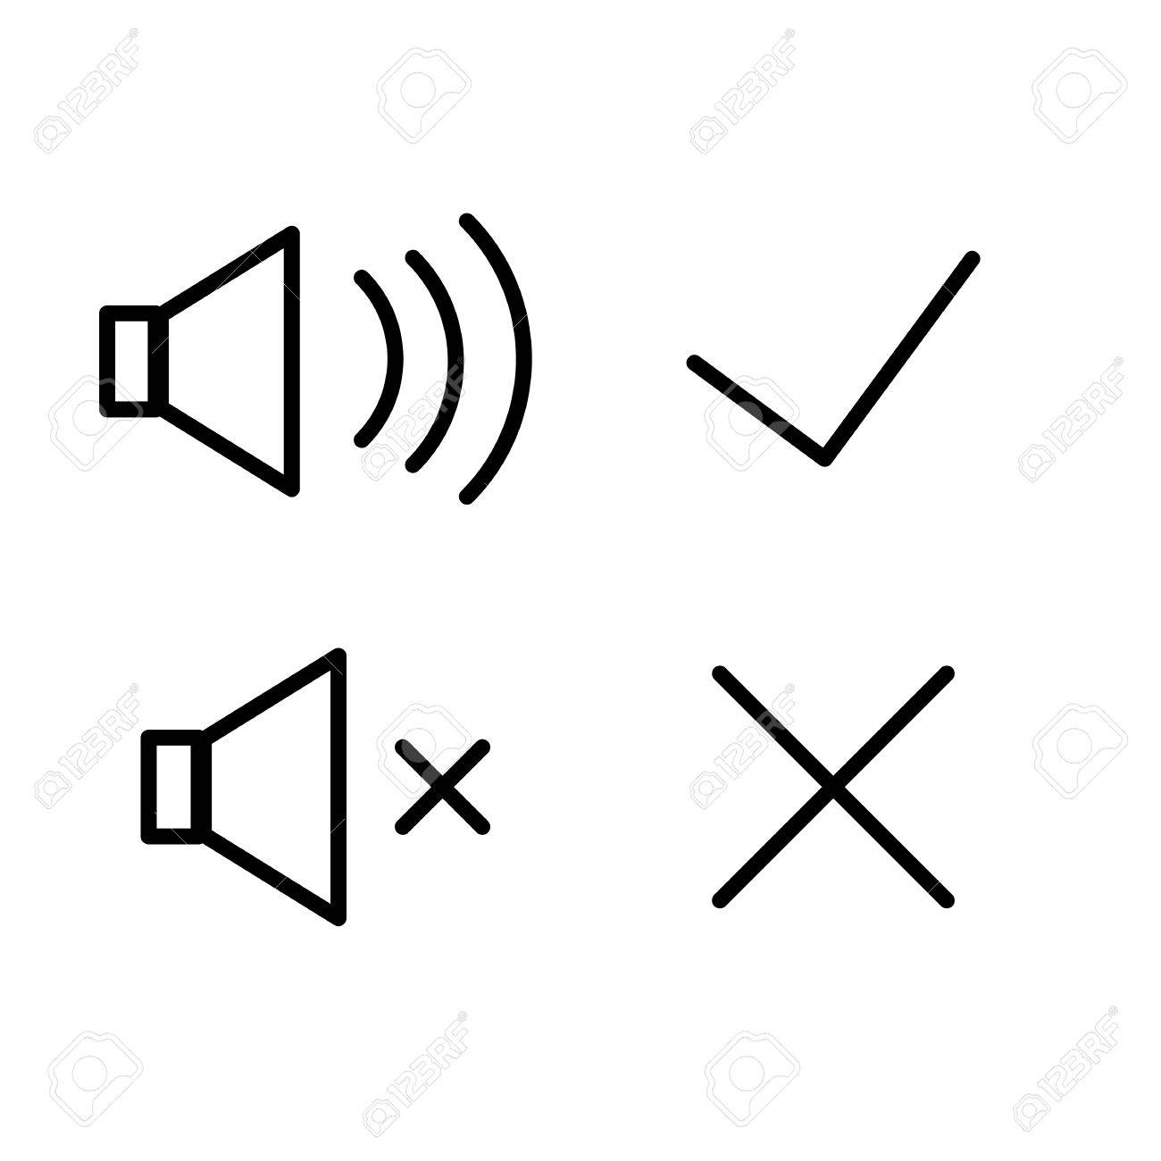
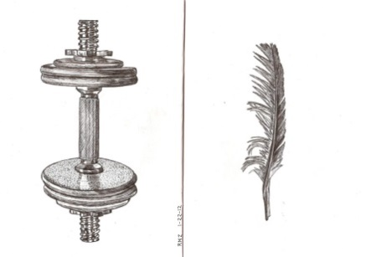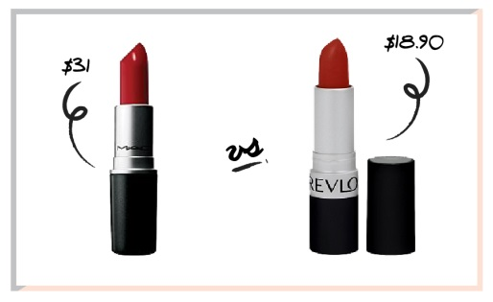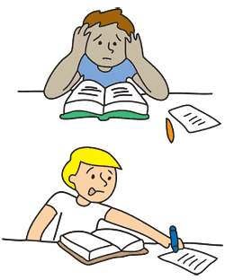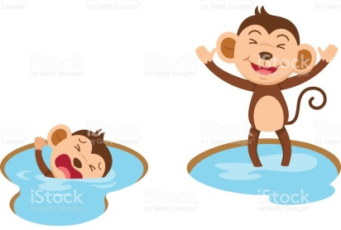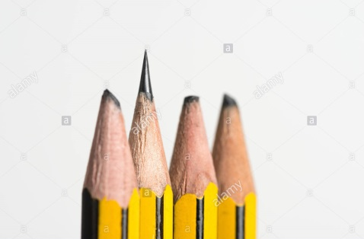
Doplňte přídavná jména do vět podle obrázků:
- The clown is ………………/…………………
- It is a …………………/an…………………… glass.
- It is ………………/…………………. morning/ night.
- The weight is ………………………./ The feather is ……………………..
- The lipstick is …………………/…………………….
- It is a …………………/a ………………. face.
- The mobile is …………………/…………………..
- It is an ………………/a……………………. task.
- The music is ………………/………………….
- It is a ………………/a…………………… man.
- The puddle is …………………/……………………..
- The pencil is ……………………/………………………..

