Scottish Cuisine

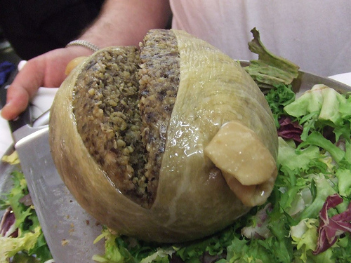

Scottish cuisine has its own distinctive features and is immensely appreciated by food buffs all around the world. Traditional dishes form the basis of the culinary traditions of the country. Scottish production is world renowned, besides smoked or salted meat and oatcake biscuits, Scots eat and export a lot of fish, particularly salmon, cod and plaice due to extensive coastal area. Nowadays, Scotland is becoming recognised as one of the world’s most exciting cheese producers, e.g. Brodick Blue cheese or Strathkinness (a Scottish equivalent of Gruyere).
A national Scottish dish - haggis is made from sheep offal (heart, liver and lungs) and minced with onion, oatmeal, suet, spices, and salt and traditionally simmered in the animal’s stomach for approximately three hours. This savoury pudding is a real delicacy for Scots. Haggis is traditionally eaten on Burns Night, on January 25, as a commemoration of most famous Scottish poet, Robert Burns (1759-1796). During festivities, Burns’ poems are read.
Besides food, Scotland is renowned for its whisky (note the spelling of Scottish whisky and Irish whiskey) known as Scotch, considered to be one of the finest spirits of the world. Scottish Ales, which are popular as well, go through a long boil in the kettle in order to get deep copper to brown colour.

.
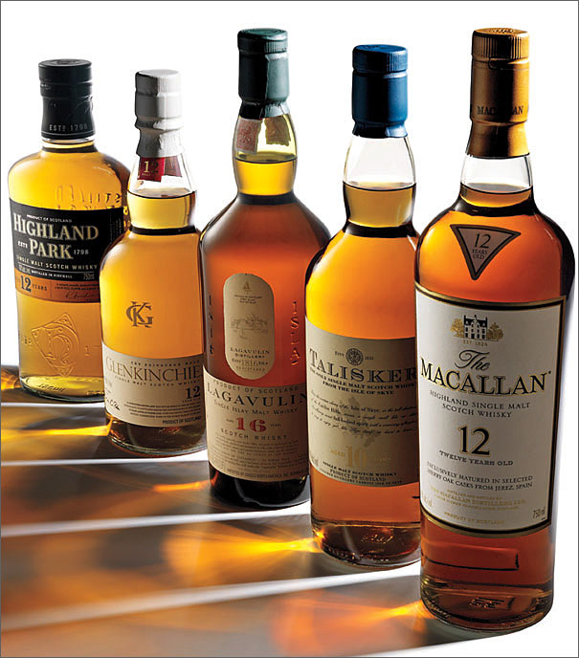
Questions:
- What does Scotland export?
- What is a haggis?
- What are the main ingredients of haggis?
- Who was Robert Burns?
- Do you know any other country exporting whisky/whiskey/bourbon? Do you like any of them?

