Giving directions:
go straight on / ahead
turn right / turn left
go along the river
go past the cinema
go over the bridge
go under the bridge
go through the tunnel
cross the street/ go across the street
take the 3rd turning on the right
walk around the lake
go around the roundabout

prepositions
on your right / left
opposite the hotel
between the butcher’s and chemist’s
in front of you
behind the church
next to the theatre
on the corner
at the crossroads

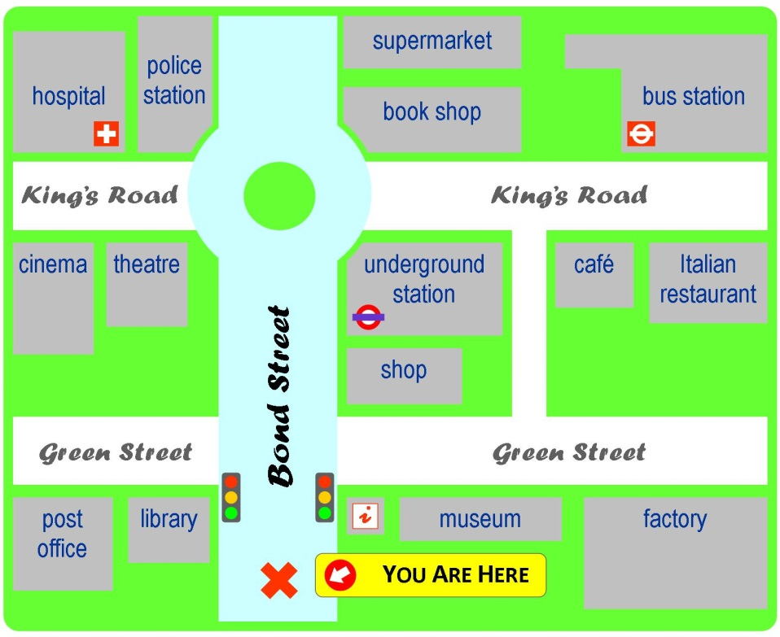

- Turn right at the crossroads, then turn left, go straight on, turn right and the
1)…………………………………… is on your left

- Go along Bond Street and stop in front of the roundabout. The
2)…………………………………. is on your right.

- go straight on, go around the traffic circle, take the third turning on the right, and the 3)……………………………… is on your left next to the cinema

- turn right at the crossroads, then turn left, go straight on and the 4)…………………………. is on your right, on the corner

- go along Bond Street, go around the traffic circle, take the second turning and the 5)……………………………… is on your left, opposite the 6)……………………………….. and 7)……………………………….

- bus station
- underground station
- theatre
- café
- police station
- supermarket
- book shop

