Peter Cottontail
Here comes Peter Cottontail,
Hopping' down the bunny trail,
Hippity, hoppity,
Easter's on its way.
Bringing' every girl and boy Baskets full of Easter joy,
Things to make your Easter bright and gay.
He's got jellybeans for Tommy,
Colored eggs for sister Sue,
There's an orchid for your Mommy
And an Easter bonnet, too.
Oh! here comes Peter Cottontail,
Hopping' down the bunny trail,
Hippity hoppity,
Happy Easter day.
Jaký obrázek náleží číslům 1, 2, 3, 4, 5, 6, 7?
a)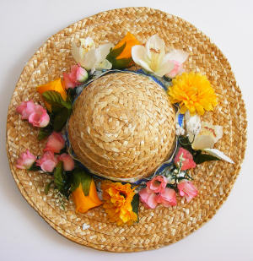 b)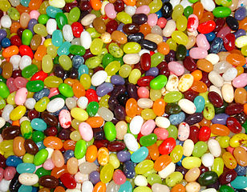 c)d)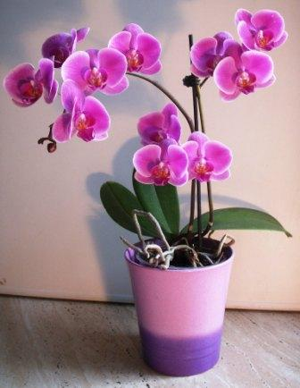 e) f) 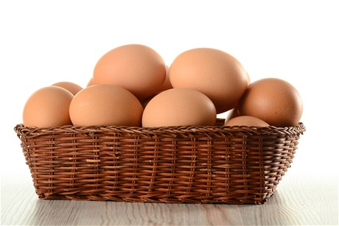
g) 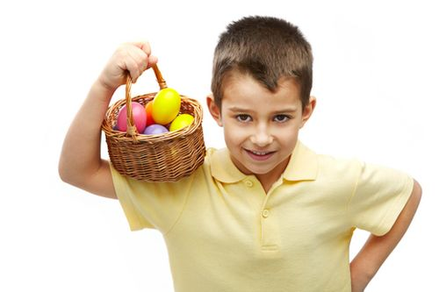Your answers: 1__, 2___, 3___, 4___, 5___, 6___, 7___
1. Who is Peter Cottontail?
a. Easter bunny b. Easter lamb c. Easter duck d. Easter egg
2. What do you do with eggs at Easter?
a. cook them b. colour them c. don´t buy them (they are expensive) :) d. fry them
3. What do you wish to your friends and family at Easter?
a. Merry Christmas b. Happy Halloween c. Happy Easter d. Happy Mother´s Day

