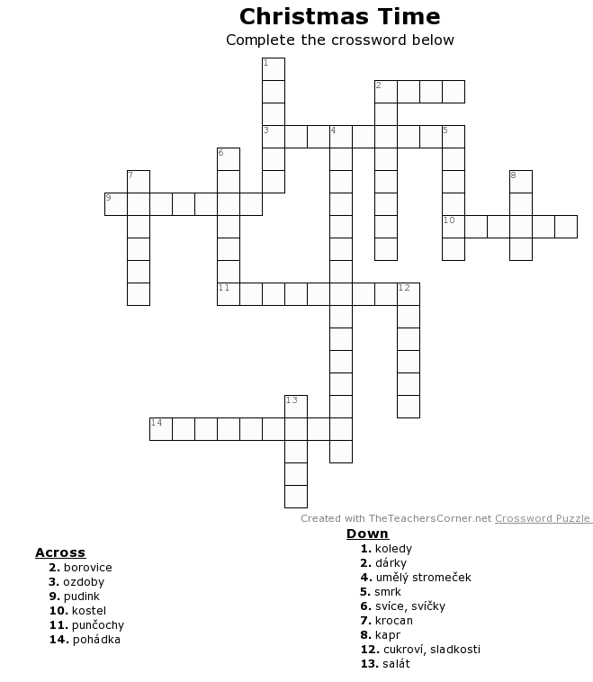
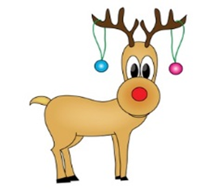
Christmas is not the same everywhere
We usually put …………….on Christmas tree in the Czech Republic on 24th of December. Some families prefer …………..or …………… but some buy only an artificial ………. We sing …………., watch ……………. on TV and light ……………. In the afternoon we go for a walk together. We also usually go to the …………….. During the day we eat …………….and fruits. Typical Christmas dinner is fried ………….. and potato ………….. After the dinner all the members of the family gather around the tree and unwrap …………….which were brought by Baby Jesus.
In the UK and America celebrations are different. Santa Claus usually brings the presents. Children wait for them until the next morning on 25th December. They can also find some surprise in hanging stockings prepared the day before. Dinner is also different from our culture. They usually eat …………… and sweet Christmas ………………...
Christmas Calendar
24th December
25th December
26th December
31st Decemer
1st January

